



Environment Configuration for MySQL Server with workbench and Navigate the MySQL GUI and CMD Usage
LAB MANUAL

Disclaimer: The content is curated from online/offline resources and used for educational purpose only
Environment Configuration for MySQL Server with workbench and Navigate the MySQL GUI and CMD Usage

Objective:
To configure a MySQL server environment, set up MySQL Workbench for GUI-based management, and practice navigating MySQL via GUI and Command Line (CMD). This ensures the ability to create, manage, and interact with databases using multiple interfaces.
Problem Statement:
Developers often need to interact with MySQL databases for development and administration tasks. GUI tools like MySQL Workbench simplify database management but require proper setup. CMD usage ensures flexibility for advanced and automated tasks. A comprehensive understanding of both methods is essential.

Requirements:
- Server Installer (download from MySQL official site).
- MySQL Workbench Installer (included with the MySQL installer).
- Administrative access to th MySQL e machine.
- Basic command-line

Procedure:
Step 1: Install MySQL Server
- Download Installer:
  - Visit MySQL Downloads.
  - Download the MySQL Installer for your operating system.
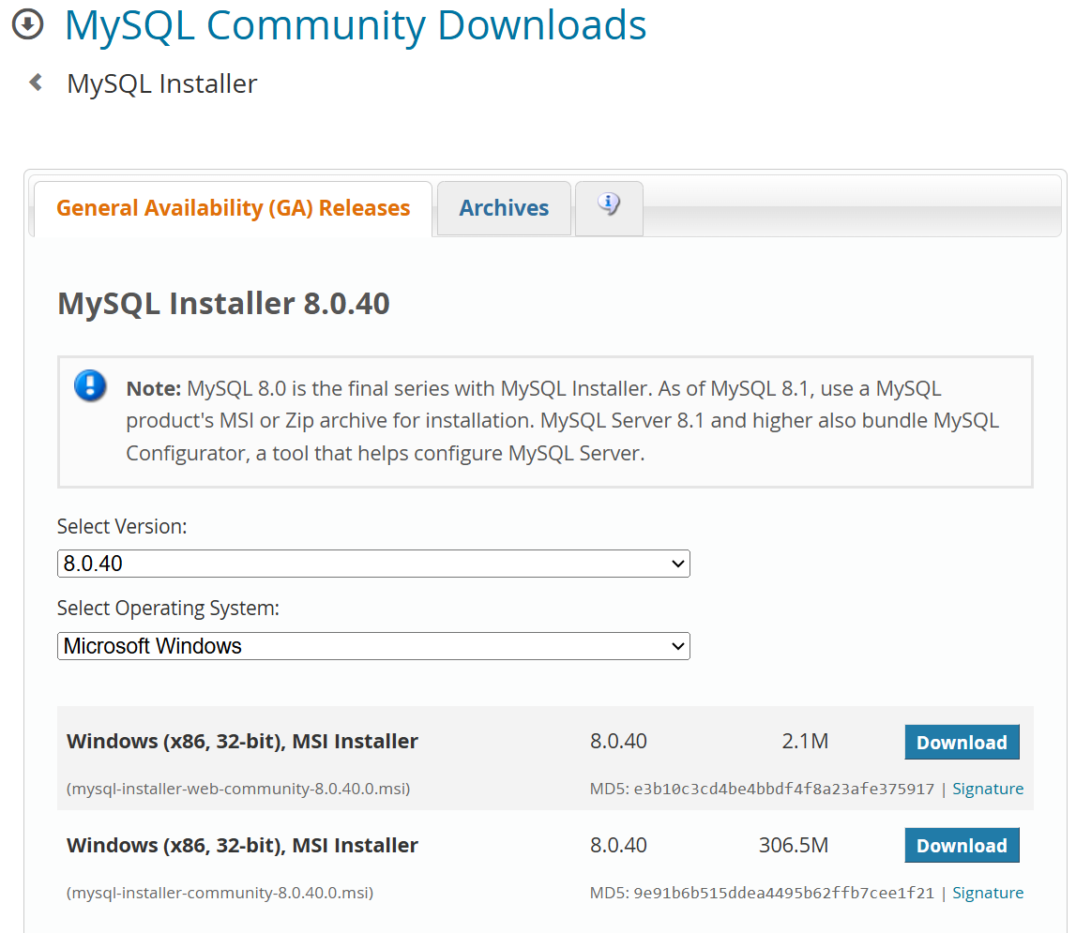

- Run the Installer:
  - Double-click the installer and select "Full" for standard setup.
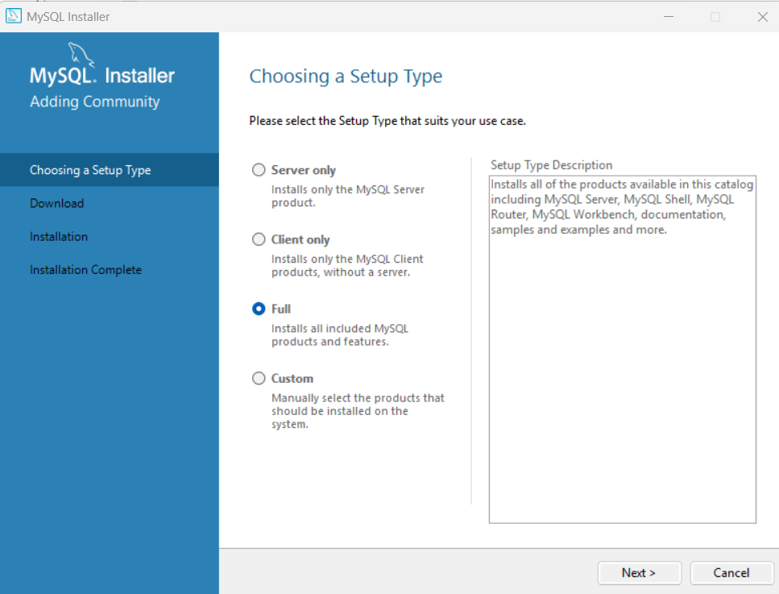

- Click Execute on the Download Page:
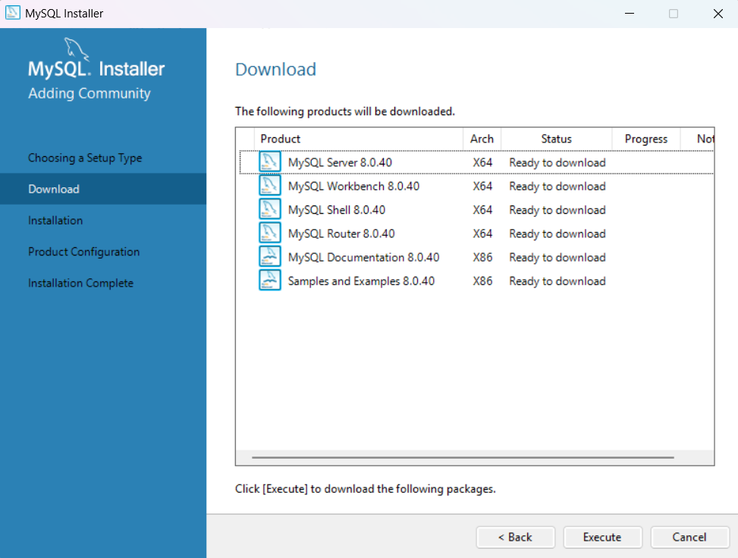
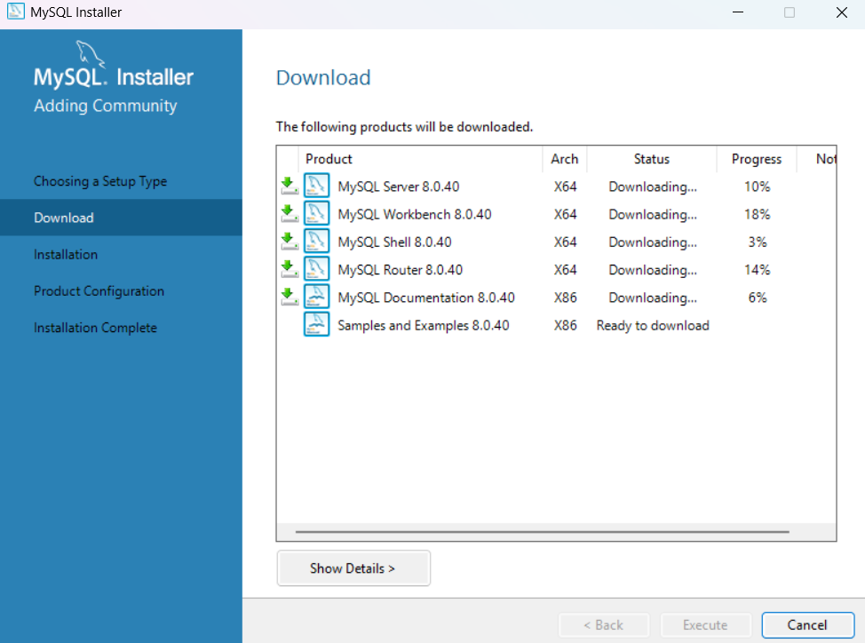

- Once the components are downloaded Click on Next to go to the Installation Page
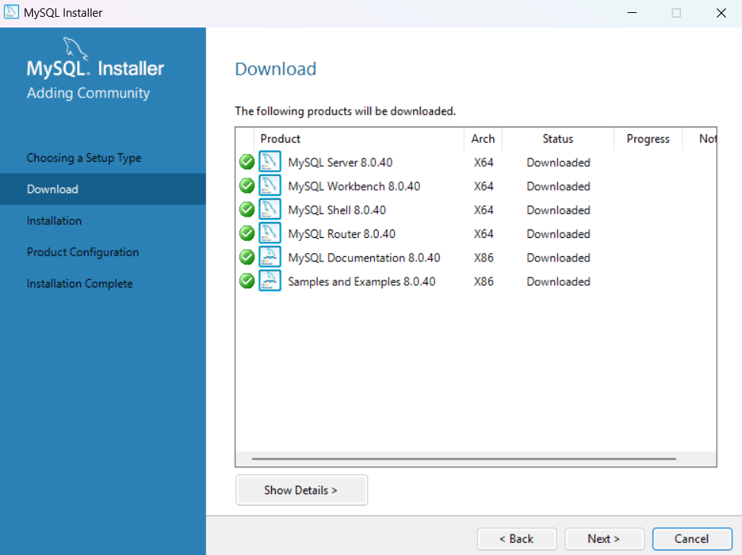
- Click on Execute on the installation Page to install the components.
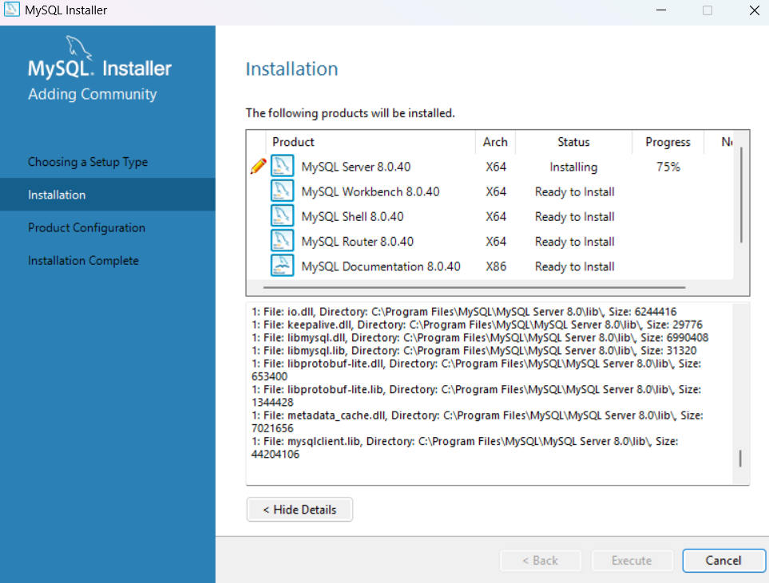
Once the installation is done, Click on Next to go to Product Configuration Page
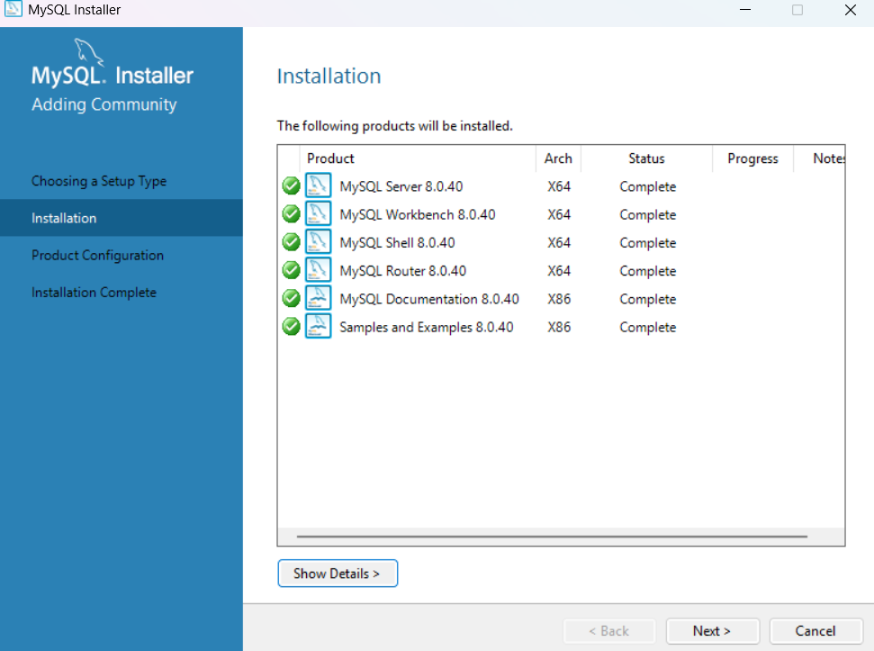

- Configure MySQL Server:
  - Choose Standalone MySQL Server and set the root password. Optionally, add a MySQL user for development or testing.
  - Set the port (default is 3306).
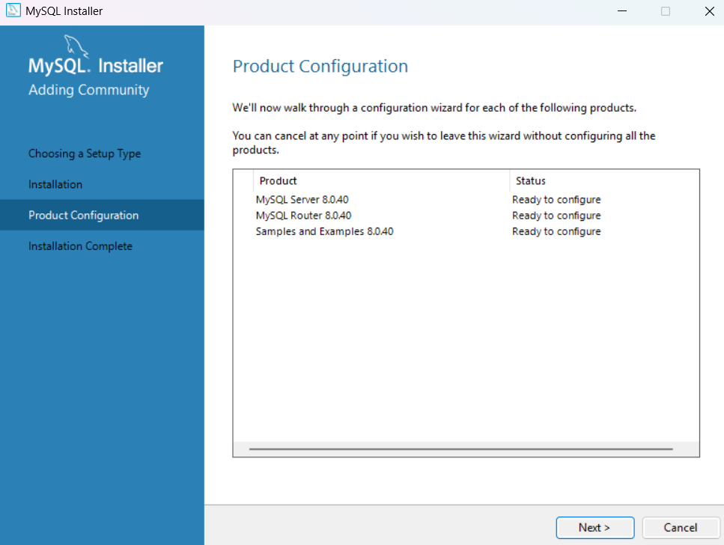

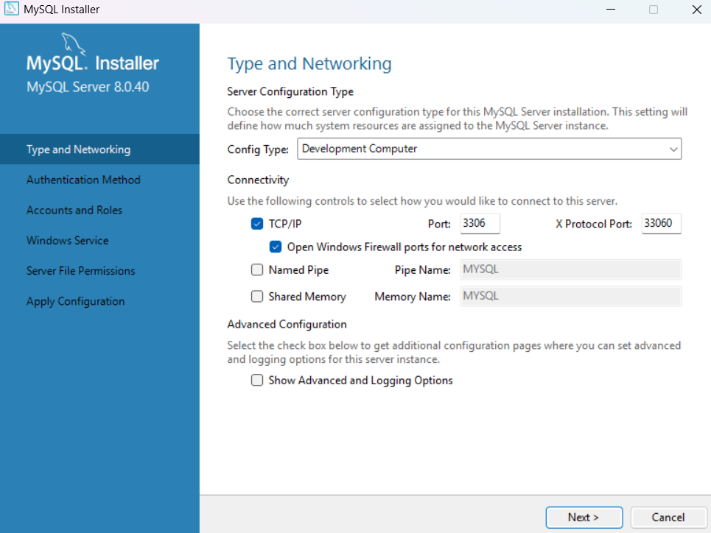

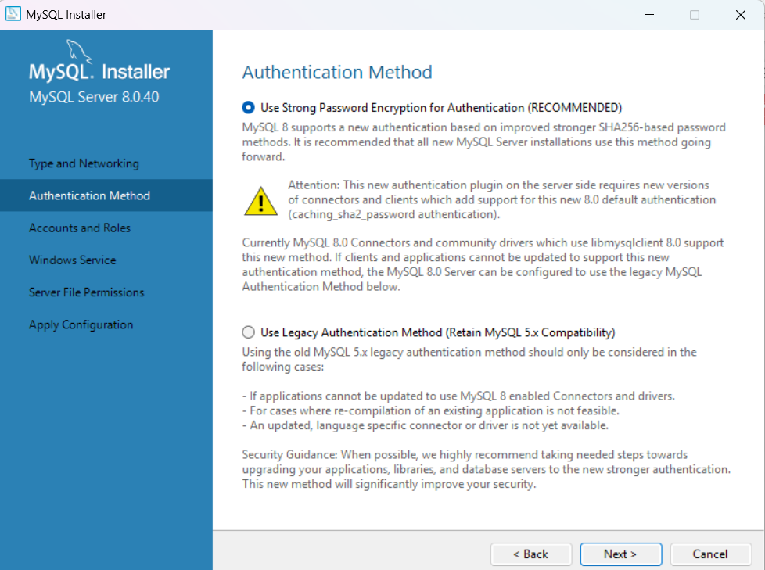

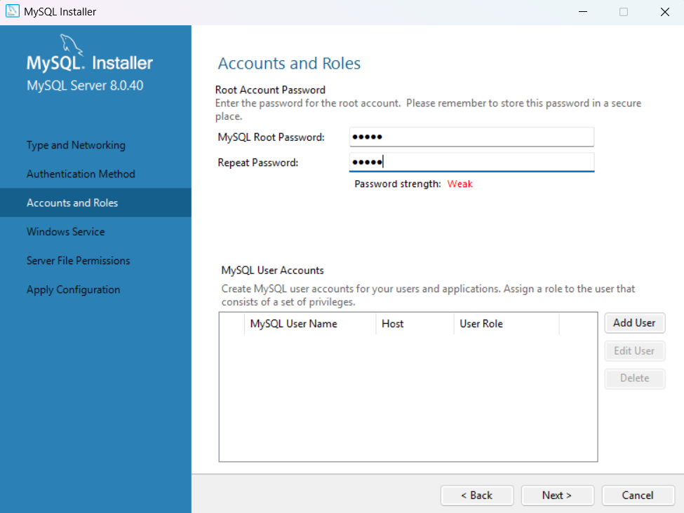

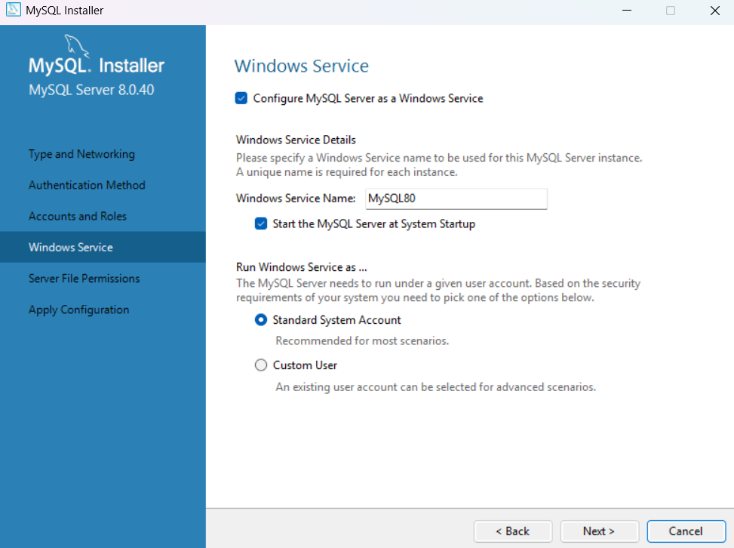

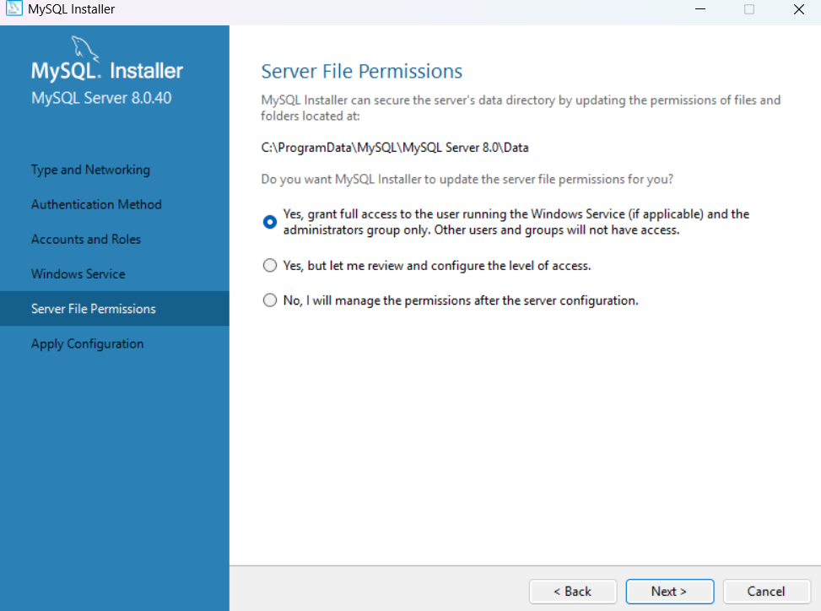

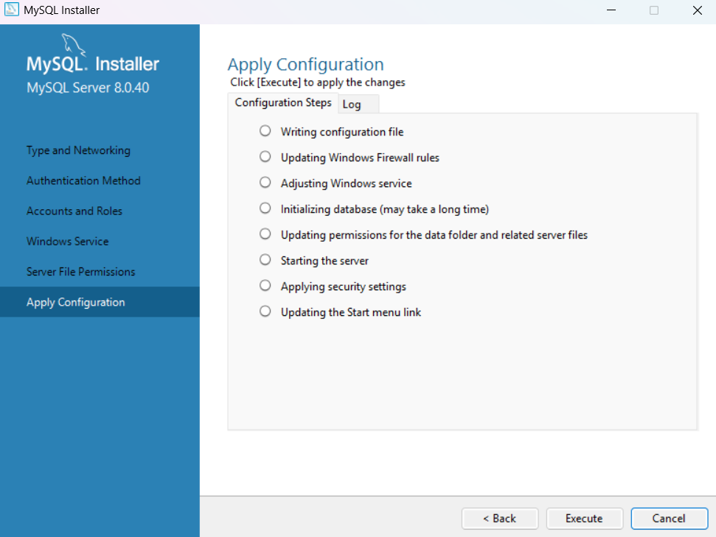

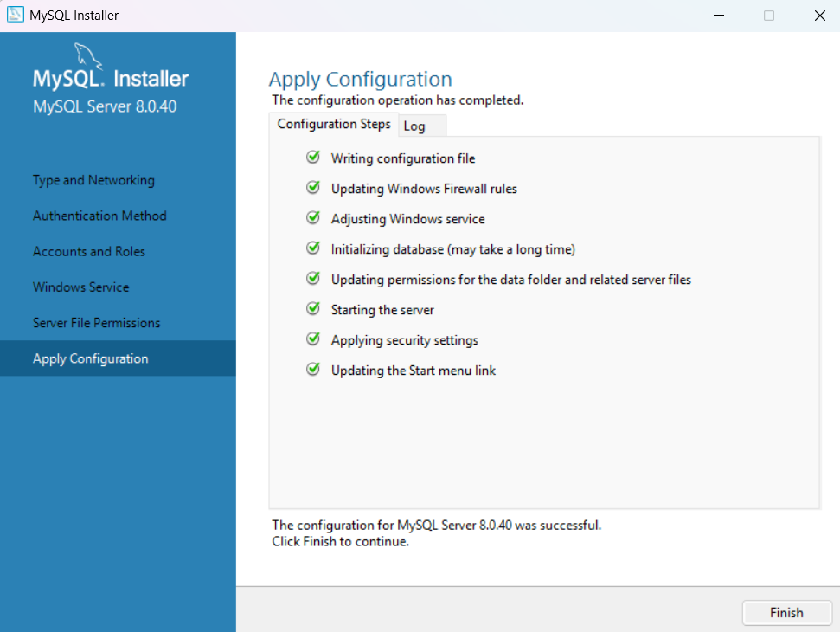

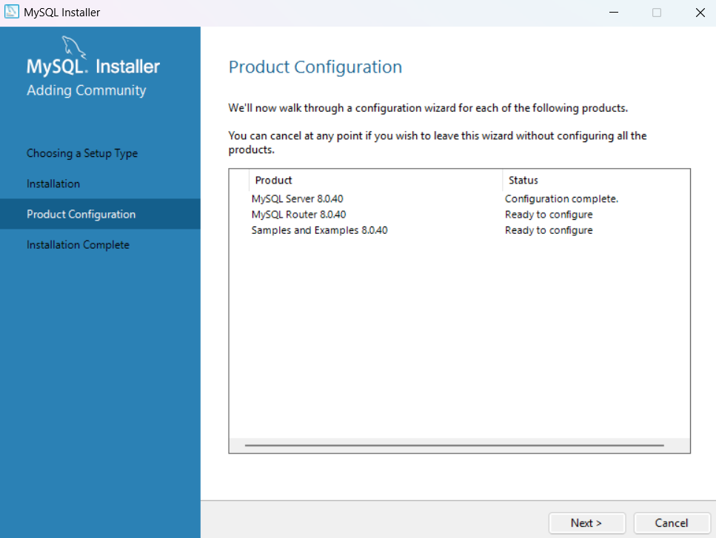

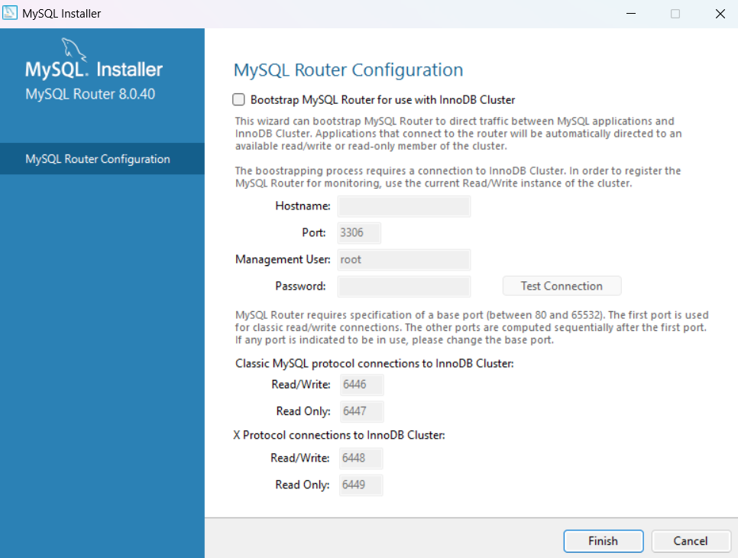

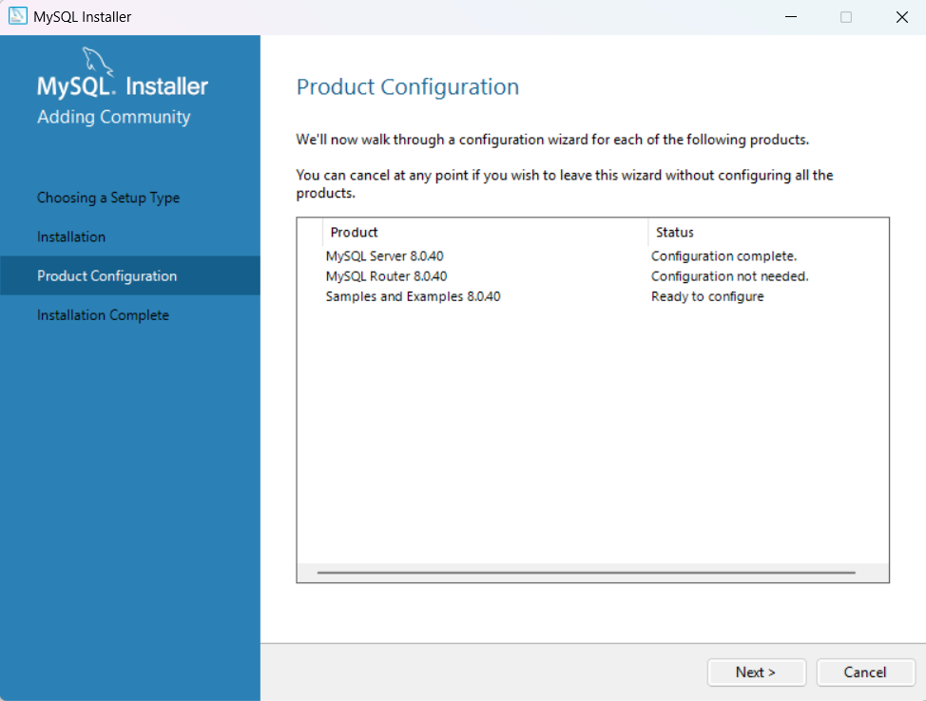

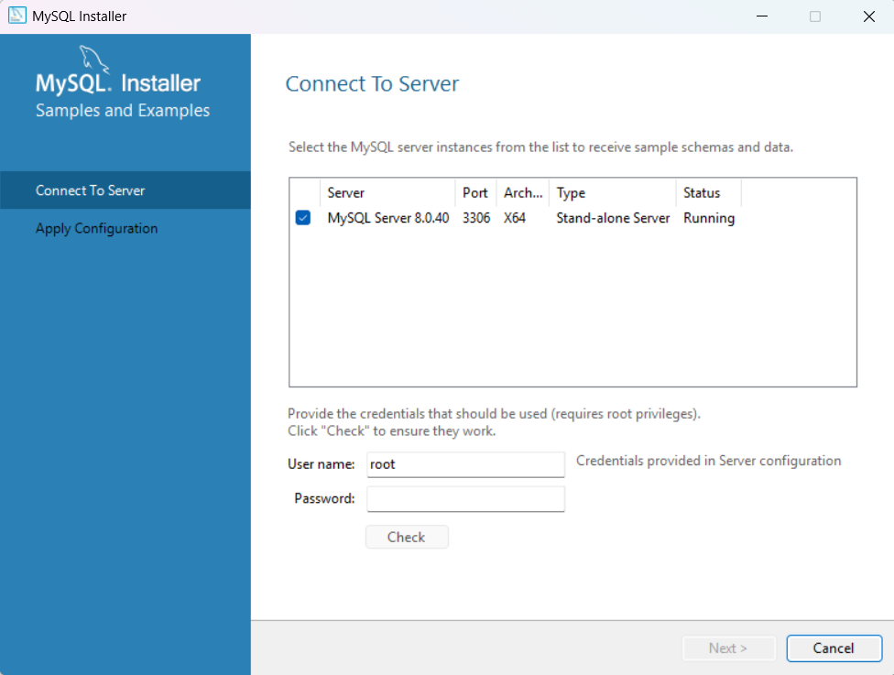c

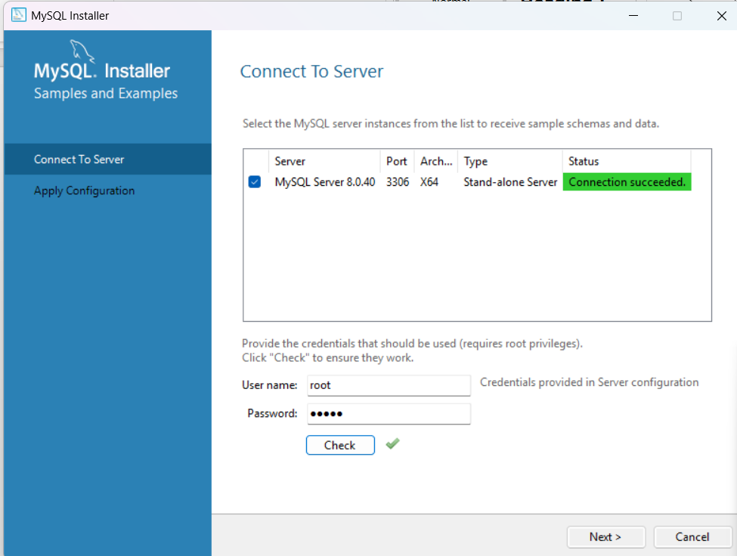

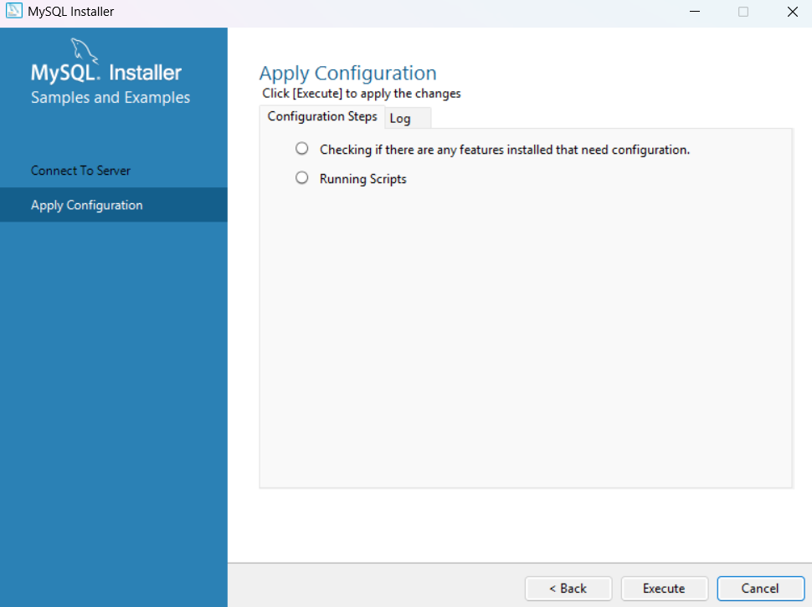

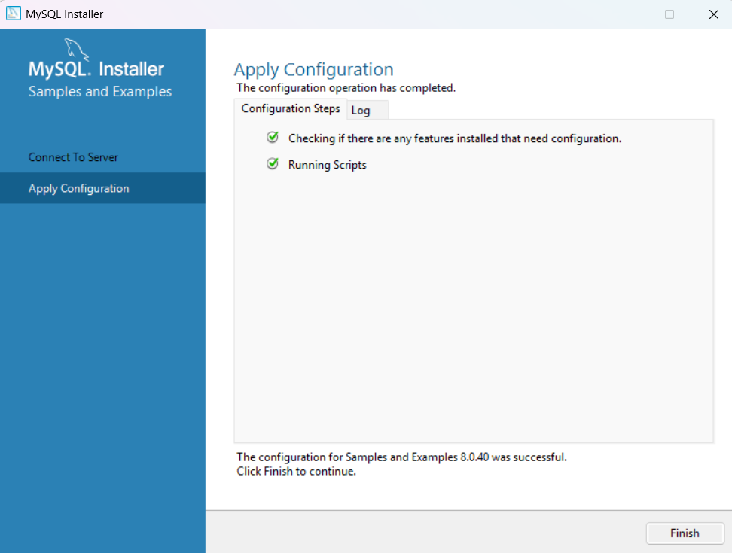

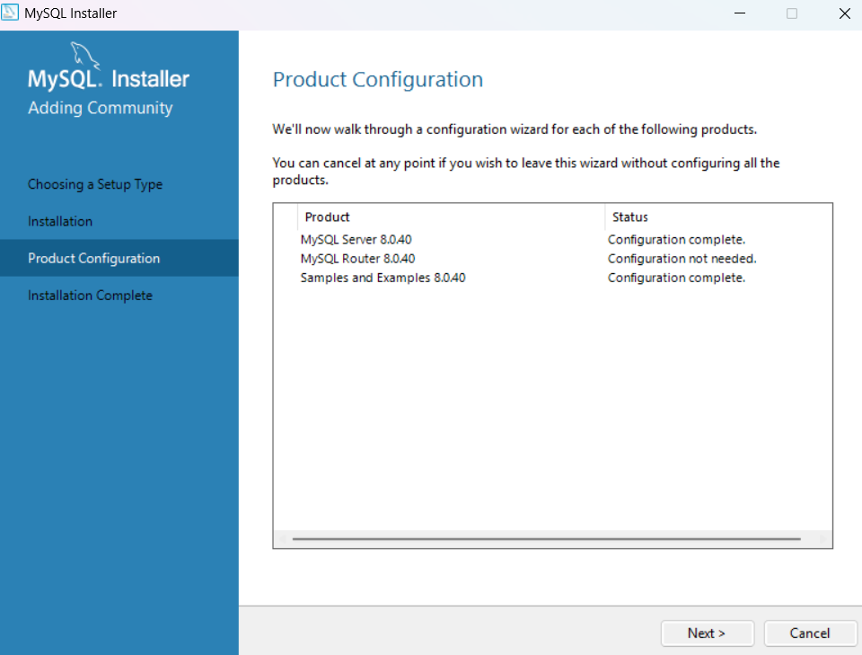

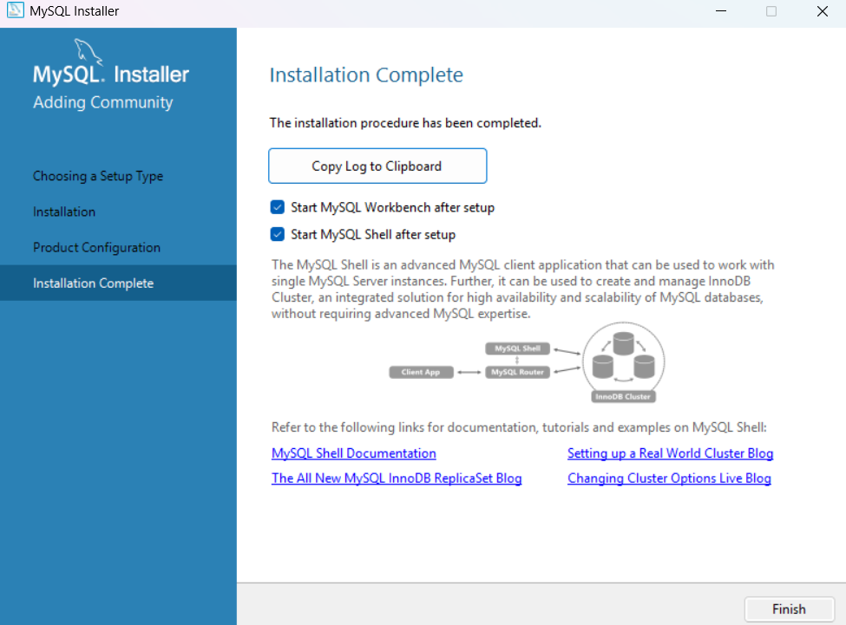

Step 2: Launch MySQL Workbench:
  - Open MySQL Workbench from the Start menu or desktop shortcut.

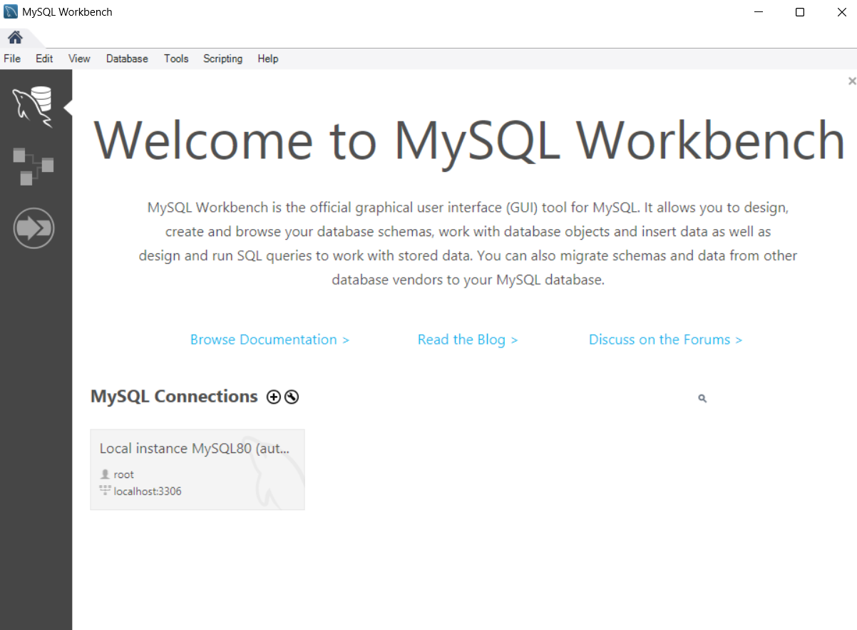

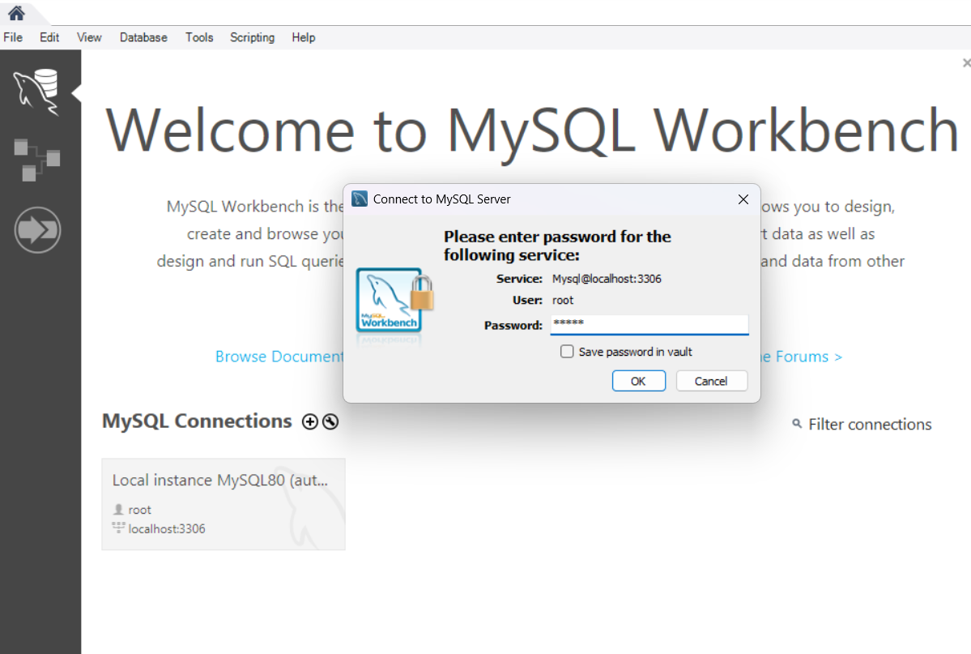

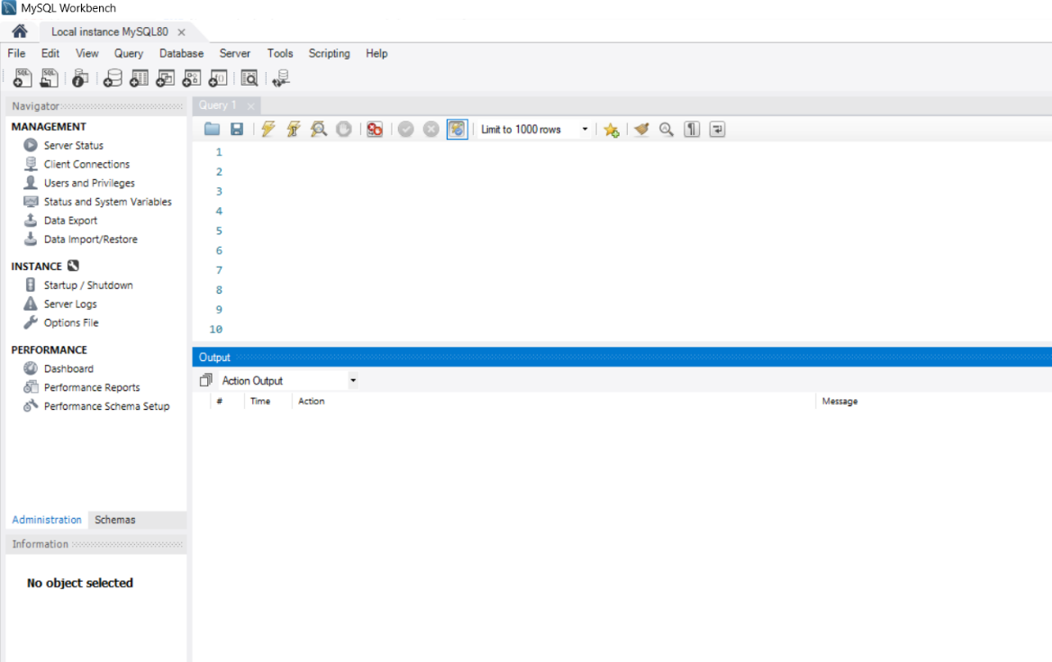

Step 3: Navigating MySQL Workbench GUI
- Create a New Database:
  - Click "Schemas", right-click in the schema area, and select "Create Schema".
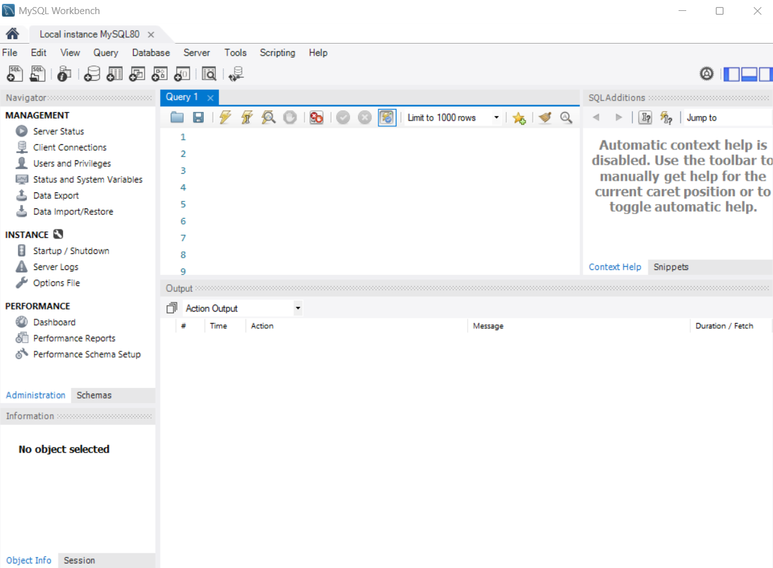
  - Provide a name for the database and apply changes.
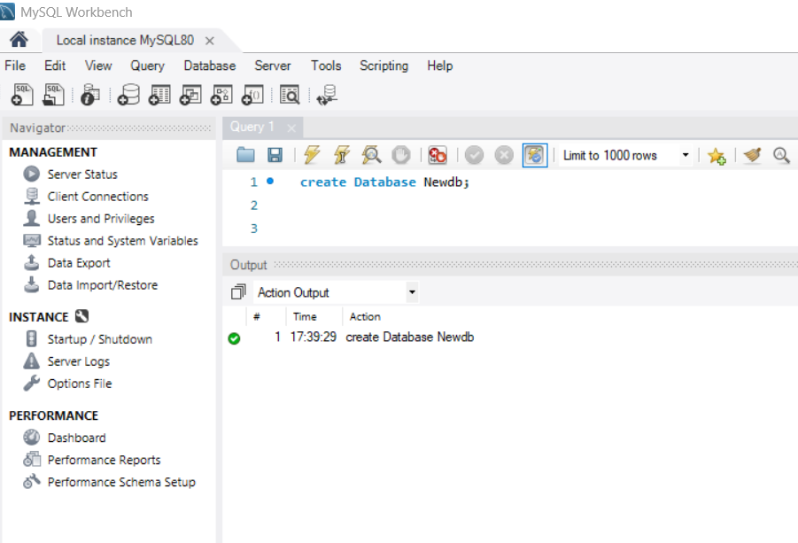

- Create Tables:
  - Use create table command to create tables in the database.
  - Define columns and data types.
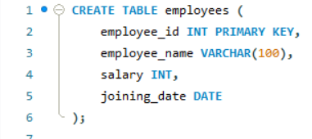
- Run SQL Queries:
  - Use the query editor to run SQL commands.

Step 4: Using CMD for MySQL
- Log In to MySQL via CMD:
  - Open CMD and run:
  - Enter the root password.
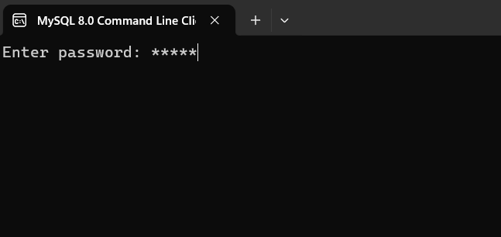

- Basic Commands:
  - Show Databases:
,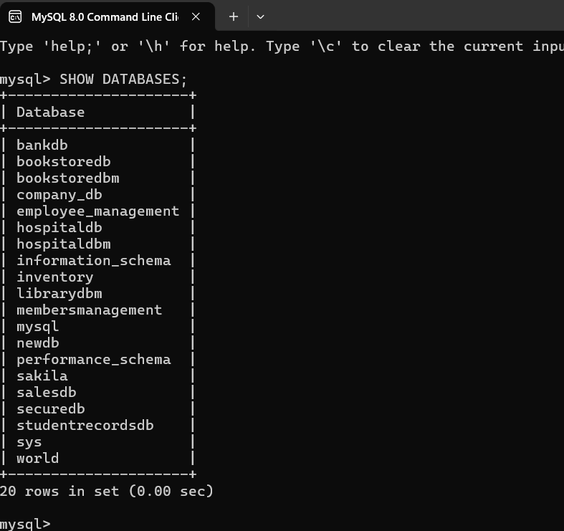
  - Create Database:
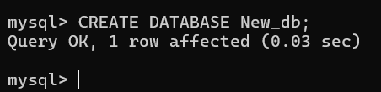
  - Use Database:

- Create a Table:
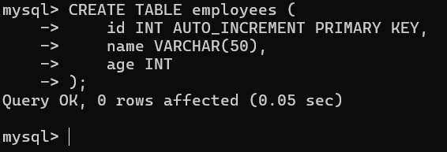
- Insert Data:
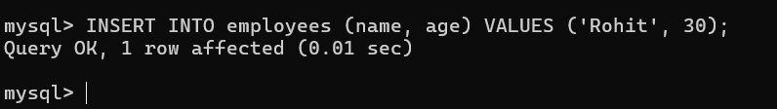
- View Data:
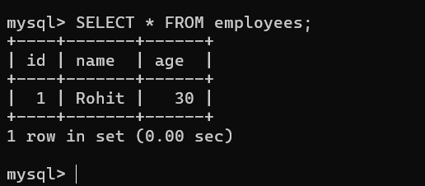

Output:
Installation and Configuration successfully completed

